Project Control Venture (PCV)

Hello and welcome to the Project Control Venture (PCV).
My name is David Winter and I am working with an expanding team of professionals to propagate best practice in Project Control throughout the entire world.
We recognise a unique opportunity with each of these target regions to effect a massive improvement in the way projects are conducted. By introducing new technologies and methodologies that will practically ensure significant improvement over current performance in project execution at all stages in the Project Development Lifecycle.
We are thinking globally, as principles of Project Control are universal. Propagating the methodology one country at a time.
Our aim is to raise the National standard for project execution and to use Project Health Control (PHC) as an enhancement to best practices in project control to oversee and facilitate the government manifestos of the current administration for each of the countries.
Regards,
The PCV Team
Downloads
'This Site as an Overview Map'
Using the overview map, you can make best use of the [XX] indexing. This helps to keep your browsing in context with the whole site.
'This Site as a Word Document'
For offline reading, the word document captures the content of this site.
Commercial Proposal
Our Proposal to potential Investors and Partners

[A] The Venture
This is a venture to set up a network of Centres for Project Management and Control.
The network is global and currently five countries are considered (Mozambique, Nigeria, Angola, Trinidad and India).
Although the characteristics of each individual region in terms of geography, politics and infrastructure are completely different from each other, the principles of the venture for each region are common.
For the purpose of further description of this venture, the concept of the 'country' is adopted as a template that can apply to any country.
We expect that the venture will begin with one of the four target countries and that this network of 'one' will rapidly increase to include all four and then gradually expand to include other countries as the venture gains publicity in the global projects market place.

[AA] Why Should This Project Start?
It's all about the value of the time spent on the project
The proportion of time needed for the project against time wasted.
The Project Control Venture recognises that there is widespread deficiency in the way projects are run. Don't believe what the average Project Team representative will tell you about his project, that it's on track, on budget, that the people on the project are fully behind the project mission, that morale is at an all time high.
If you revisit these people at six monthly intervals, you will hear them all make the same speech but about a project that is often substantially different at each six month stage to what it was before.
Projects move on, they grow, the spending continues and reaches a point at the end where everything is done, all deliverables delivered, the gas production facility (to use an example) is all finished and operational.
And the whole thing has cost a certain amount, let's say 3bn (that's 300 million). The accountants take that figure as the cost of a production facility of that type. Other similar facilities are built with that figure as a kind of template.
But there's a big question here. Does it really need to cost that much? Well there's nothing much we can do about the cost of materials (steelwork, concrete, wires etc) but for the operational cost of running the project, costs related to people (time billing, stationery, heating, lighting, food) the question of how much is 'needs to be spent' is significant. A badly controlled project will take longer to complete and use more resources than a well run project.
This project - the project control project, needs to start, as a first step to reclaiming billions of unnecessary spend from the world's projects.

[AB] Why Project Control?
When we're talking about project success or failure, we're really talking Project Control, and the reason is purely economic. This becomes intuitively obvious when we consider some of the things that hinder a project's progress.
(1) Central information becomes fragmented and localised so the right hand of the project becomes less and less able to know what the left hand is doing.
(2) People leave, taking their own personal bubble of knowledge with them. That knowledge has to be either recreated or the project has to somehow go on without it.
(3) Project Concerns arise during the normal course of the work and there are often numerous meetings called to discuss them. Often the Concerns in a project relate to the use of resources and deficiency in communication.
(4) Email culture takes hold in the project alongside 'blame culture' as back covering activity dictates that everyone is emailed with updates on sensitive topics. People in the circulation feel obliged to respond, whether or not they have some useful input because they imagine their lack of reaction can be seen by peers and management as some kind of weakness. Email trails like this can go on for weeks as each person in the circulation tries to score points that he hopes will help him keep his job.
(5) People cast their own personal economic outlook onto the project. An obvious effect of that is the tendency for individuals working on the project not to want it to end! People on a project can take all manner of day to day difficulty, as long as the cause of the problem can't be attributed directly to them.
(6) Enthusiasm is not an automatic feature in a human. Levels of enthusiasm vary hugely in the project workforce over the span of a project. Imagine a project where the enthusiasm of the entire workforce is transformed to the highest level throughout the project. Making a project where every single individual in the workforce actually WANTS the project to finish as early as possible.
The vast majority of projects of all types and sizes currently in progress in the world are flawed.

[AC] Why Project Health Control?
Project Health is all about visibility and communication.
A healthy project in our definition is one where the deliverables are clearly defined and their status known precisely on a day to day basis. The processes used in our project health control system serve to feed that definition continually. And those processes are followed mainly by staff dedicated to the Project Health Control function. There are some processes for the whole project staff to follow, but these relate to accessing the PHC lists and feeding information about the changing status of deliverables and on problems that arise while doing the work.
Staff see PHC as something both useful to their daily work and easy to feed with update information. The data gathering, organisation and analysis work that is done by the PHC consultant is specialised and is done by a combination of site based personnel and remote admin staff.
Management see PHC as a window into the workings of the project. The dashboard views alone offer a valuable insight on project progress, but with the feedback mechanism in place and working, for a PHC enabled project it's like 'having eyes and ears everywhere on your project. An immensely useful tool for project control and risk and issues management.
A common objection to implementing the PHC process relates to the perception that something 'extra' has to be bought by the project to 'help' with its successful delivery. Something that is not necessary as projects just work, don't they?
This is a dangerous assumption, when we consider that for a project near the 'death' end of the Project Health scale, cost is likely to escalate, and the date for achieving revenue is going to be pushed further out.

[AD] The Feedback Cycle
The idea of the 'suggestion box' is old and good! Project Health Control takes the concept of the suggestion box to the limit. The project staff's interaction with the PHC data collection systems works like this:
(1) He logs into the database and sees a simple dashboard that shows him what Concerns, Deliverables and Actions are assigned to him.
(2) He selects an item and works on it just as he would normally, leaving a window open to the item for background reference while he works.
(3) During the work, if something notable happens, he writes a brief message in a 'feedback' text box and presses the submit button.
(3a) If the notable thing is that he has finished work on the item, then that's what he types as his feedback "finished work, document stored".
(3b) If the notable thing is that there is a problem that prevents him from continuing, then that's what he types for his feedback "work suspended, need information on [x] from [y].
(4) He bounces around from item to item, doing as much as he can on each and giving his feedback until his day is over.
(5) Next day, he logs into the database and this time what he sees on the dashboard is a revised set of Concerns, Deliverables and Actions that reflect the feedback that he entered the previous day.
It's a continual cycle, and everyone on the project is doing this, all day every day. Normal work, as they normally would, feeding back to PHC admin 'snippets' of status information.
The feedback system is completely unobtrusive to the staff's normal work and each day they log on to see what is 'on their plate' in a continually changing project work landscape that is continually fresh with updated status.
For a manager, the dashboard is different and includes tools to allow drill down into various levels of detail and the manager has facility for reporting on metrics for project status and 'work to' lists for monitoring work progress.
For the PHC consultant and administration staff, the dashboard is different again and gives access to tooling that allows them to do various activities like data mining, and merging and tagging of data in the PHC lists. It is the work that the PHC team does that makes the daily access by the project staff work smoothly.

[AE] The Communications Network
Still on the theme of the feedback system as a huge 'suggestion box', on a project, in a local environment where everyone is near an office, where there is good internet access, where everyone is computer literate, the PHC browser login feedback mechanism of course works very well.
But even in a project situation, there is sitework in the field, geographically distributed makeshift offices, and often keeping basic power continuity is a problem. Getting feedback data into the PHC systems in these cases generally revolves around the efforts of desk bound field service coordinators with a stream of field staff dropping by to give status reports.
This works! But the system works in a much better if feedback can be generated at source. In this situation, the field service coordinator takes on the role of a PHC administrator for his part of the project and the PHC systems for metric viewing and reporting makes his job much more easy and enjoyable.
An integral part of the Project Control Venture is the Communications Technology brought by Delina Televentures. The DT Communications Network is an innovation in itself, providing a means for remote communications in rural areas, creating new possibilities for rural businesses to operate as part of the national supply chain for goods and services.
The DT Communications Technology in a Project setting allows each of the staff to carry a hand held device that is always available to access the PHC lists for the project for anywhere, anytime feedback of project status.
Applying this to the Government scale Transformation project, the DT Communications Technology is a crucial 'enabling factor' for getting feedback from the entire length and breadth of the nation and into the massive database that forms the Government's PHC lists.

[AF] The Investment Proposition
Very simply, we are nurturing a service that can transform the effectiveness of any projects to produce performance statistics that by current industry standards are unbelievable. We've been involved in this nurturing for several years to date and we're looking for a trial project to apply prove our claims. The trial project is the trigger for an expansion in demand for the service that will reach global proportions very quickly.
To convince a project owner to take a chance on supporting this innovative service is not easy. As a means to get to a trial project our strategy is to sell into our marketplace a number of software packages that have an easily recognisable benefit and that use the principles of the methodology behind the service. When we have built a substantial customer base for these packages, this will be our target market for securing the Trial Project. If the trial project achieves the success we predict, then the flood gates open for propagation of the service to satisfy huge global demand.
This Project Control Venture is effectively mitigation for the risk of runaway success.
We are doing the groundwork to prove the service and we would not expect to attract major investment before the trial project is achieved. But we do expect to attract the interest of major investors for injection of capital when the time is right.
On a country regional basis we are looking for investment of 10 million to develop the service around a training centre and resource pool for each region.
Break even in 1st year with £0.8m injection (10m comfort buffer)
Year 1 - £1.4m net profit on £6.8m tunrover
Year 5 - £40m net profit on £139m turnover - 2,000 people on 420 projects

[AFA] Where to Start
There's this thing called PHC. Project Health Control.
It's a figment of my imagination, or at least it seems like that sometimes, a lifelong dream. A vision that's in it's 16th year now, that's getting more and more real, very soon I think to come into reality.
I know that the question is there in your mind already, "Why should I invest in someone's dream?" Well the answer is and has to be simply money. Lots of it, on a worldwide scale. But this is not a restaurant chain, or an accountancy firm. This is a service based methodology that, if it can be proven to work on one project, will work on all projects everywhere, in the whole world. The demand for this service will reach the stratosphere and will become very hard to control. We'll need a strong management team to control the growth, and huge injection of capital, phased in individual campaigns for expansion country by country. The management team you see now in this venture will not be the management team that I'm describing here. We are a team of engineers, managers and administrators. We'll do the groundwork and make the service work. Then pass the whole thing over to people who are used to global economic development.
We're looking for a major investor with the potential to take this through it's entire development, not to come in right from the start, but to stay 'interested' in the concept as it develops to a point where huge investment is needed. At that point there will be projects in their hundreds that are taking this service. Probably spread among several countries. The first major investment will be to develop one country and take ALL its projects as a national policy for treatment using PHC. But more of that later in this report. There's a lot to do before that.
We're also looking for incremental investment, to help us get off the ground. As there is only so much growing we can do organically, and always there will be the prospect for a sudden demand that has to be met with an influx of resources.

[AFB] The Vision
So again, there's this thing called PHC.
It's about keeping clarity on the Project's deliverables, and processing the project's Concerns like Risks but including Issues (a Concern is either an Issue or a Risk).
Most people in the Risk world stop at Risks, but I developed the PHC methodology on the basis of that notion being crazy. The control (and tracking) of Actions to mitigate Risks is exactly the same as it is for solving Issues. But most Risk Engineers will proudly tell you, "that's not a risk, it's an Issue, not in my domain".
A bit like going through the whole seduction process and then at the moment of conquest giving the girl (or boy) to someone else!
Most people in the Engineering world don't really know what the project deliverables are. Even those deliverables for which they are directly responsible. Take any 10 people in a project's department and ask them for a list of their deliverables and you will get 10 non-identical lists. It a PHC enabled project, ALL deliverables are defined and tracked, with precision.

[AFC] The Order of Development
Let's imagine for a moment, without yet fully understanding why, that PHC applied to a project is hugely influential in bringing about its early completion. That this is proven by its application to a succession of numerous projects. Everyone wants PHC on their project.
What do we imagine was the turning point; from no-one knowing what PHC is to everyone wanting it on their project? Well, it's the testing of the whole concept on the whole of a project, with the PHC implementation fully supported by the project's management. A 'trial' project.
To get to the trial project, we need a base of 'interest'. We intend to create that interest by deploying a network of PHC 'puppies' each of which has the potential to grow teeth. Each of these puppies will be not a full PHC implementation, but will be a useful tool for managing the project's Risk, that works on PHC principles. Giving the management of each deployment a 'feel' for how it works. Each deployment will have training on its Risk 'puppy' that can lead into a full deployment later, on a trigger point.
So we have then, a network of projects that each has their PHC puppy, each one thinking tentatively about taking the plunge and declaring their project The Trial Project!
In practice this transition is very hard to achieve. We've been looking for the trial project for 5 years. It is understandable that no-one is going to trust their project to us with this crazy PHC thin that's not tried in the industry. Would you??
Actually it is tried, not just a bit, but quite a lot. But in parts, sections of a project, various trackers used in isolation, and the principles applied as they have developed over this past 16 years.
But there is in fact a way. This PHC puppy idea. We sell a little bit of PHC into a project then into another project then another, until we have built up a critical mass of projects that we can use to do a marketing campaign to find the Trial Project. We tried that before but without the benefit of there being little nuggets of PHC scattered all over.
The little bit of PHC means different things to different viewers. (a) to the project - just a tool, (b) to the project owners (with other future projects in mind) it's an interesting curiosity to see if it can grow or to see if someone else's little bit of PHC can work. 'They take the risk and we watch', (c) PHC investors - same as 2 but more to gain, (d) the PHC people (like me) - each is a chance for a trial project. Each is a source of income while the development happens.
What exactly is this 'little bit' of PHC? - it's a register conversion, the project gives us its risk register and we help them to run it as a risk (and Issues) tracking tool. It's a view into the PHC methodology, because it uses the PHC lists for absolute clarity of the risks.
Want to know more? - ask

[B] The People
This is about making projects work across the whole nation, not just a few projects, but every single one, and it's about the establishing of a pool of Project Controls Professionals nurtured within a network of schools (or colleges) dedicated to the training of nationals, for attachment to these projects.
It is also about the establishing of the Government Transformation exercise as a project itself. A huge undertaking that will absorb a good proportion of the output from the national pool of Project Controls Professionals. There will be NO waste of manpower as the entire compliment of this output will be 100% utilised.
The project will be developed for one or more of the five target countries at first, but eventually the pattern will be replicated to cover every nation in the world. This is a programme with a central control office that is likely to be started and maintained in the country of the first government that agrees to commit to the venture.
As far as People population of the project is concerned, there needs to be a two tier management level. The first tier manages the Network of established schools. The second tier is dedicated to each nation and manages what goes on in the school set up in the country.
There is also the concept of what could be considered an intermediate management tier for those countries where there is more than one school set up in various sub-regions. This is effectively an extension of Tier 1.

[BA] Tier 1 People
Tier 1:
The enterprise management team - technical, finance, marketing, operations.
The board - ceo, management team representatives.
Investment partners - [institutional investors, shareholders, banks]

[BB] Tier 2 People
Tier 2:
The local management team - technical, finance, marketing, operations.
The board - ceo, management team representatives, government representatives.
Clients - project owners
Staff - Trainers, trainees, graduates, administration.

[C] The Plan
The timing for propagation of the Project Controls service involves a combination of several factors over time. The Plan is set for 5 years and various scenarios are considered.
The plan to date is a result of intensive work on building a financial model that applies to one region

[CA] Phases
The project is conducted over three phases.

[CAA] Feasibility Study
The purpose of the feasibility study and the initial 120K is to bridge the gap between development to date and the start of project.
The key ingredient that's missing is input from the government, without which we're can't go any further.
Estimate for cash requirements for the feasibility study is 120K, a relatively small amount for a commercial investor to supply.
There is an advantage to finding a project services company who could fund the feasibility study as an investment with the potential to attach themselves to the hundreds of projects that the venture would be accessing, for service opportunities.
The feasibility study could also be funded by the government who could place one or more directors into the board of the venture for close monitoring and involvement.
There will still be need for investment for the venture as it gets underway. The amount of investment needed with current projections is 800K but this will change as a result of the feasibility study.

[CAB] Startup
The main part of the project, to which the financial forecasts begin to apply, is the Startup phase leading on to rollout.
Startup is planned for the first year of the plan (2014) and will include the simultaneous development of three pilot projects and the PHC training facility.

[CAA-A] Set up Training School
The PHC principles are protected by IP law and are implemented using a system that is easily scalable. The venture is started using a core team of existing PHC consultants and a first wave of 60 PHC candidates is trained intensively during the first 6 months of operation on the pilot projects.
All are immediate deployed on the first project that buys into the service. All are paid for by the venture, some are charged to the project to a loose formula related to the size of the project.
Some of the compliment of 60 will be real Project Controls engineers (fully experienced expats that use PHC principles) the rest will be promising local graduates having graduated in a project management or controls related discipline.
Those that are not deemed chargeable to the project will be working on the project while training, for free. The project provides a source of project information that they can use for training. The project owner is aware of this and is fully supportive. The idea is that the PHC methodology for enhancing project transparency and communication, as it is essentially non-interfering with project execution, can be deployed to whatever extent the project wants.
The first project takes advantage of the abundance of available help, even though it is 'novice' help during the first few months of training. As more projects are achieved the same principle is carried on as further gradual intake of students tracks the increasing number of those that become chargeable.
Eventually the student intake levels out as the achievement of new projects reaches equilibrium. The financial model is based on PHC deployment alone and is yet to be adjusted to incorporate straight sales of training services, which will tend to reduce the cash injection needs and bring the break even point forward.

[CAA-B] Pilot Projects
Pilot projects are selected from a number of candidate projects offered by companies in the Energy Industries during the pre-election phase.
The plan for trial projects involves one for each of the categories we identify for forecasting purposes. Though the actual size of projects undertaken and the number of PHC staff appointed to them will vary greatly.

[CAA-BA] Small
A practical low limit of project size for application of PHC is £10m
PHC Projects Small Scenario.pdf
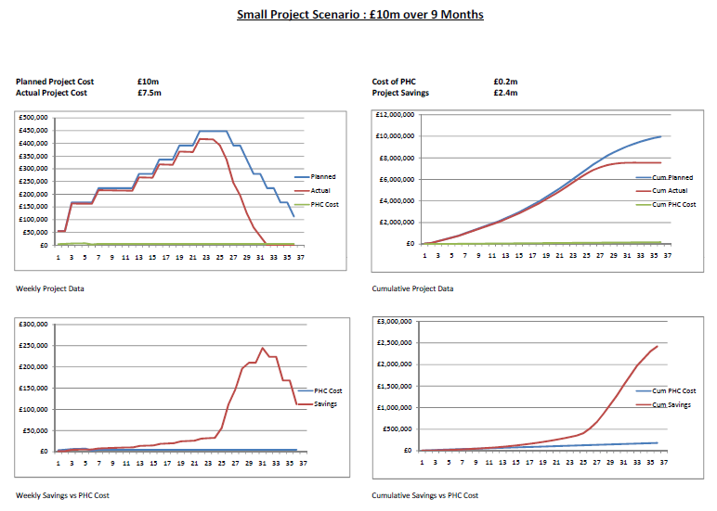

[CAA-BB] Medium
The majority of projects is expected to be in the mid-range £650m
PHC Projects Medium Scenario.pdf
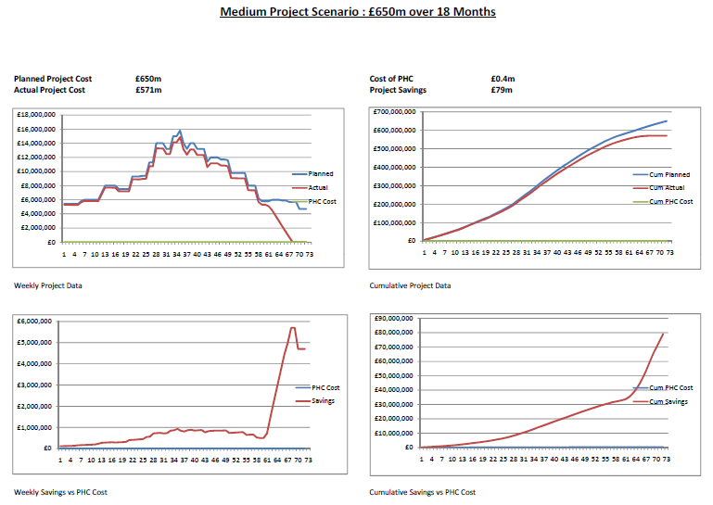

[CAA-BC] Large
A large project we consider in the order of £3bn
PHC Projects Large Scenario.pdf
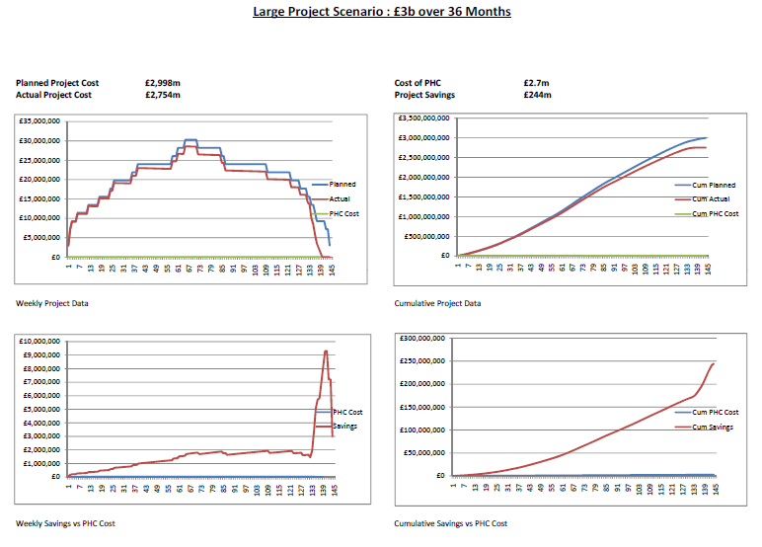

[CAC] Roll Out
The roll out is the steady growth of the application of PHC to emerging projects. The starting of projects is related to the rate of emergence from the PHC College of basic- trained PHC staff.

[CB] 5-year projections
We project a 5 year period for development of the enterprise into an equilibrium state achieved at the beginning the 5th year.

[CBA] Illustrations
We show the forecast growth using a financial model that resolves to comprehensive and detailed financial reports. The model is intended to illustrate the possibilities for growth. Actual progress will be recorded and reported using standard accounting procedures and the forecast model adjusted in all three scenarios according to the emerging reality of project economics.
Target Scenario P&L Chart
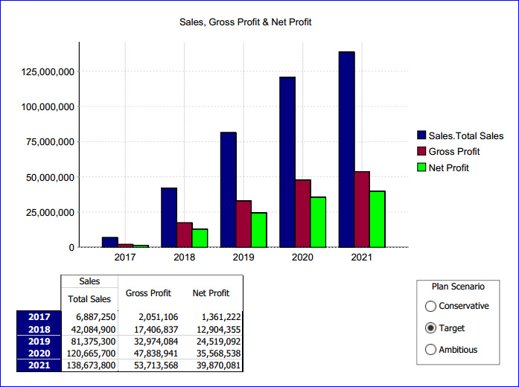
All growth scenarios are identical in the first year. Subsequent years differ in terms of rate of deployment of services on projects.
Conservative Scenario P&L Chart
Ambitious Scenario P&L Chart

[CBA-A] Profit & Loss Statement
PL_Summary.pdf
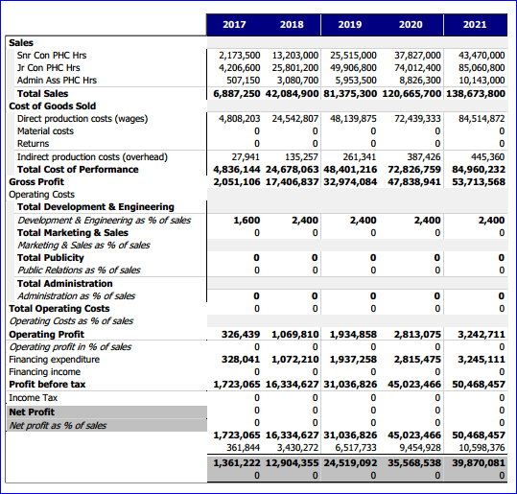
PL_Detail.pdf

[CBA-B] Balance Sheet
BS_Summary.pdf
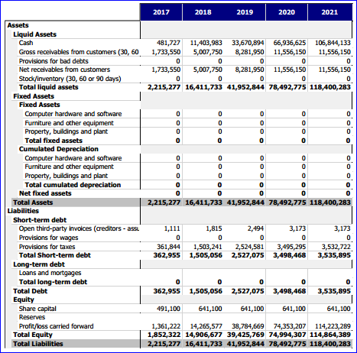
BS_Detail.pdf

[CBA-C] Cash Flow Statement
CF_Summary.pdf
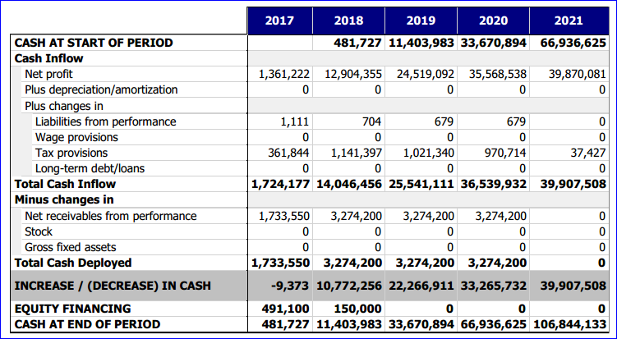
CF_Detail.pdf

[CBA-D] Income & Expenditures
IE_Summary.pdf
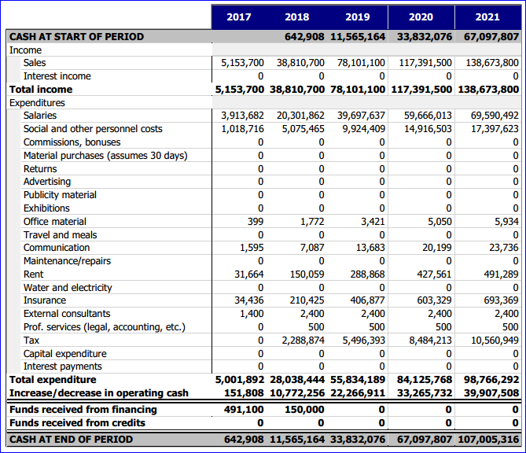
IE_Detail.pdf

[CBB] Scenarios
We propose three scenarios, each of which follow a separate set of growth assumptions.
The Target scenario is the focus throughout the venture and the Conservative and Ambitious scenarios are for illustration of the possibility in cases of lower and higher achievement of projects on which to apply PHC.
Target Growth Scenario
All growth scenarios are identical in the first year. Subsequent years differ in terms of rate of deployment of services on projects.
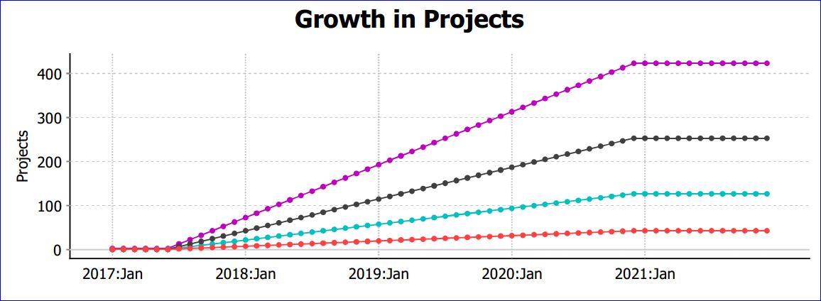
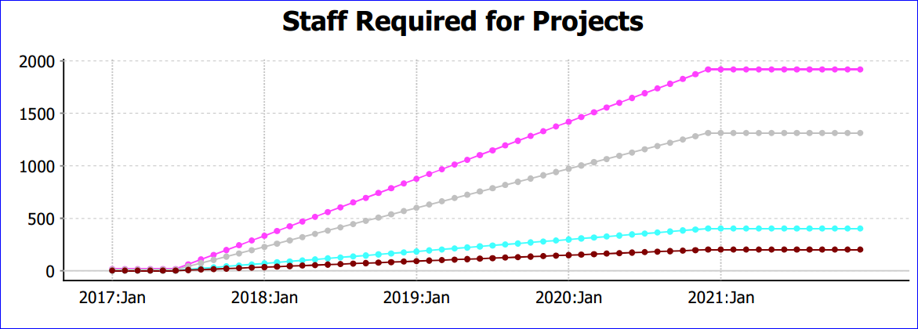
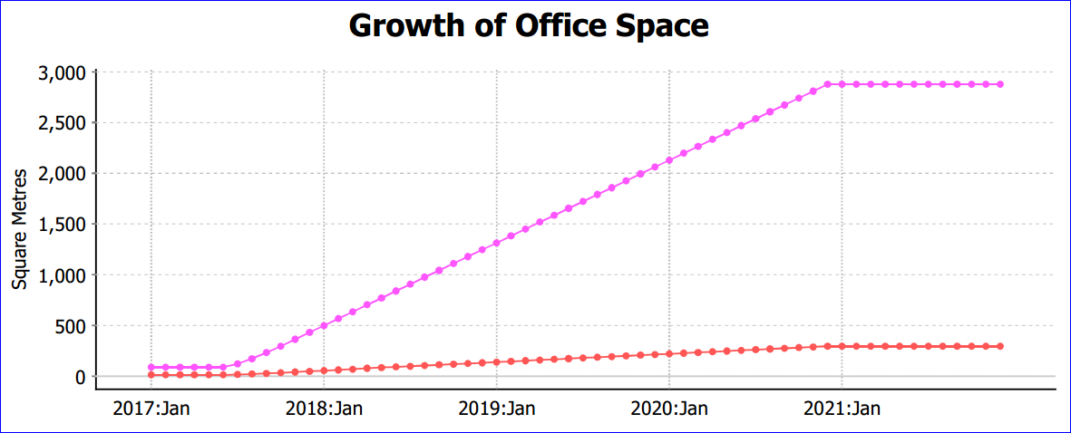
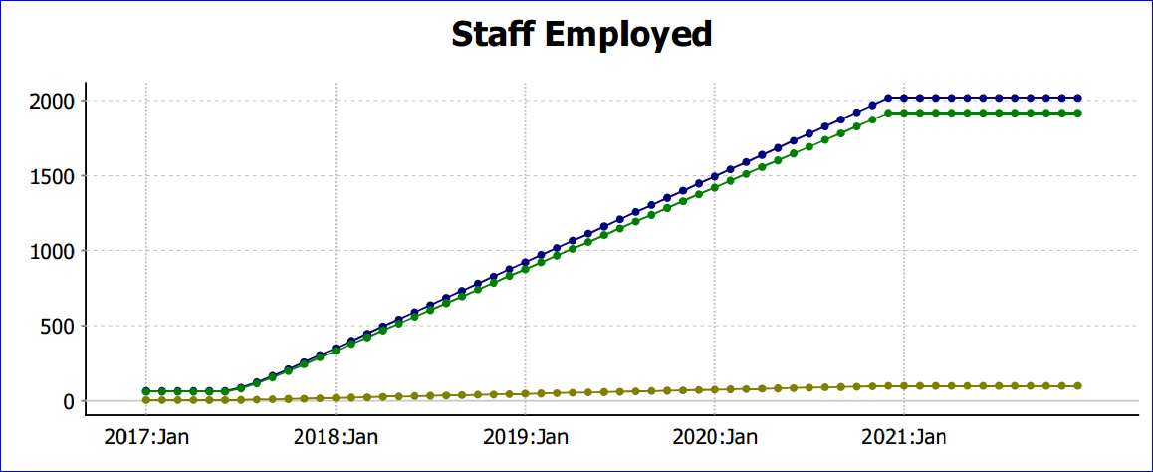
Conservative Growth Scenario
Ambitious Growth Scenario

[CBB-A] Year 1 (All scenarios)
£1.4m net on £6.8m
Break even in 1st year with £0.8m injection

[CBB-B] Target
Year 5 - £40m net on £139m
2,000 people on 420 projects

[CBB-C] Conservative
Year 5 - £29m net on £99m
1,400people on 300projects

[CBB-D] Ambitious
Year 5 - £51m net on £178
2,600 people on 550 projects

[D] The Projects
The main focus of the venture is to apply PHC to Projects.

[DA] The Portfolio
Though PHC has its roots in the Oil and Gas Industry, it is a methodology that encompasses all kinds of project and therefore all industries. Some industries are chosen as targets for emergence during the five year plan into industries key to national success.

[DAA] The Oil and Gas Industry
The major revenue producer. PHC applied to the nation's Oil and Gas projects is intended to generate an entirely new source of revenue, from a new- found efficiency in the industry.

[DAB] The Power Industry
Long overdue development of India's power industry will be a necessary part of the nation's development. Application of PHC will enhance this development significantly.

[DAC] The Water Industry
An integral part of the nations development is the water industry and the obvious associated health benefits of an abundant clean water supply.

[DAD] Agriculture
The furthest target for development, once the PHC methodology is underway and integrated within the Indian culture, will be the agricultural industry.
India's agricultural capacity has been a long overdue candidate for contribution to the nation's internal needs as well as potential for revenue generating exports.

[DB] Each Project
The Venture offers a commercial service to Client companies and does not 'assume' take up under government mandate or directive.
We achieve management (and project staff) buy-in by offering the PHC service as a progressive cost/risk free trial basis.
The venture also offers conventional Project Controls consultancy and operational services.

[DBA] Free Feasibility Study
Each project starts as a free Feasibility Study. This takes around four weeks and allows the setup of PHC systems, to enable the client to see how the service can work.

[DBB] Risk Free Trial
After the Feasibility Study and presentation, work progresses to the Risk Free Trial, which is an extension of the Feasibility Study, but with PHC staff on site. During this time (around 4 weeks) costs are accrued at the company's risk pending agreement to sign off by the Client.

[DBC] Continuation
Progression into the Continuation phase is seamless and continuation is based on time billing to a cost ceiling that is set progressively by the client throughout the project's duration.

